**DATA ANALYTICS ON ROAD ACCIDENTS**

*O Pandithurai R. Kennady A. Arthi*

*Associate Professor Associate Professor Head of Department*

*Department of Computer Science Department of Computer Science Department of Artificial*

*and Engineering and Engineering intelligence and Data Science*

*Rajalakshmi Institute of Technology, Rajalakshmi institute of Technology Rajalakshmi Institute of Technology,*

*Chennai, India Chennai, India Chennai, India*

[*pandics@ritchennai.edu.in*](mailto:pandics@ritchennai.edu.in)[*kennady.r@ritchennai.edu.in*](mailto:kennady.r@ritchennai.edu.in)[*arthi.a@ritchennai.edu.in*](mailto:arthi.a@ritchennai.edu.in)

*Bavatharani G Balapremika* *K Dhanasree K*

*Artificial intelligence and Artificial intelligence and Artificial intelligence and*

*data science data science data science*

*Rajalakshmi Institute of Rajalakshmi Institute of Rajalakshmi Institute of*

*Technology Technology Technology*

*Chennai, India Chennai, India Chennai, India*

[*bavatharani.g.2021.ad@ritchennai.edu.in*](mailto:bavatharani.g.2021.ad@ritchennai.edu.in)[*balapremika.k.2021.ad@ritchennai.edu.in*](mailto:balapremika.k.2021.ad@ritchennai.edu.in)[*dhanasree.k.2021.ad@ritchennai.edu.in*](mailto:dhanasree.k.2021.ad@ritchennai.edu.in)

**ABSTRACT**

***One of the primary causes of car accidents is speed. If emergency services had been able to learn about the tragedy and arrive in time, many lives might have been saved. Today, GPS is an essential component of a car's system. For the analysis, a scatter plot was created in Python. Kepler.gl has been utilized by us to locate accidents. Road accidents cause injuries, deaths and financial losses, Making them a major public safety concern around the world. A summary of a sizeable data analytics study on traffic accidents is given. From the given dataset we have taken latitude, longitude and speed of the vehicle and we have used a data visualization tool to display the accident zone.***

**INTRODUCTION**

India ranks first in the world for the number of accidents and lives lost on the roads. India has only 1 % of the vehicles in the world, but has 11% of the accidents in the world.We have used python to build a scatter plot for the analysis. This ongoing procedure of locating and fixing zones contributes to increased road safety and a decrease in accident rates. A dataset has been offered in order to visualize and locate the unintended locations. By analyzing data and using various visualization techniques, we can determine the likelihood of accidents occurring in accident zones. According to research on "Education Influence on Traffic Safety" and "Effect of Road Safety Education on Road Risky Behaviors of Spanish Children," warning of impending problems before they happen is likely to lower the number of traffic accidents by 70% to 76%.

**DATA SOURCE**

From the given dataset we have taken areas, number of vehicles, latitude, longitude, date, time and speed of the vehicle and we have used a data visualization tool to display the accident zone.

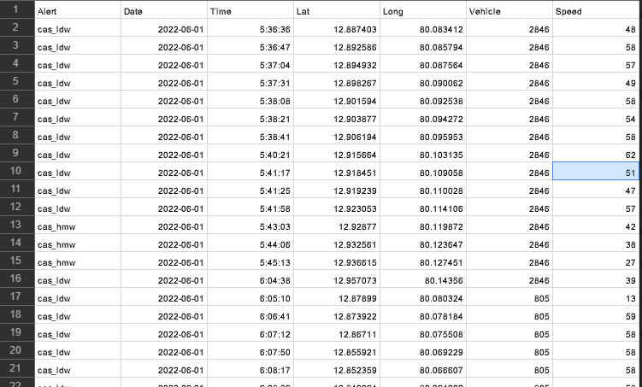

The datasets which we have taken is given by intel organisations.The dataset includes the accidential areas and the speed of the vehicle which is the major cause for the accident.The dates and times of the accidents are given.The accident that occurred during the year of 2022 are given.

**ANALYSIS**

After a thorough analysis of the warnings issued by Advanced Driver Assistance System,it was discovered that the Headway Monitoring and warning alert(cas_hmw) was the one that occurred the most-12,328 times-while the Forward Collision Warning alert(cas_pcw) was the one that occurred the least-599 times.According to the likelihood table,there is a possibility of roughly 0.578 that headway monitoring and warning will occur.Therefore,the cas_hmw alert had detected the bulk of accidents. If a vehicle approaches another too near, the cas_hmw warns the driver. Therefore, we may conclude that the majority of incidents have resulted from sudden passing of vehicles from behind. The accident analysis based on the submitted vehicles and alerts is shown in the graphic below. Each variety is distinguished from the others by the color variant.

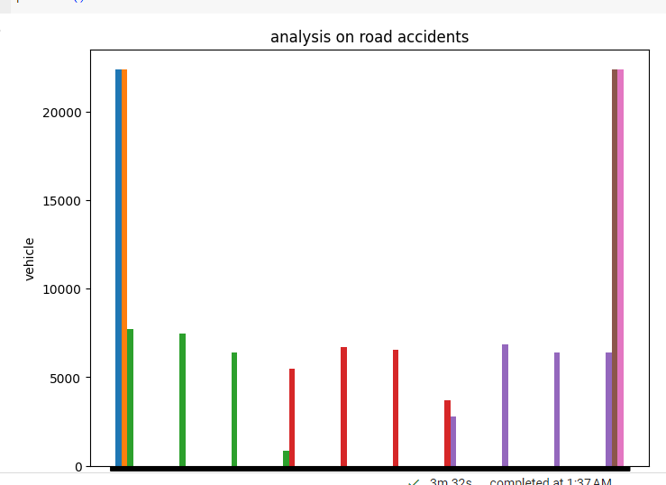

**CONCLUSION**:

Therefore, this project can help us to detect the accident zones and reduce the number of accidents on Iroads. Since the accident locations are predicted earlier, the emergency services can be provided easily.

**REFERENCE PAPER:**

* [https://towardsdatascience.com/visualizing-geospatial traffic-data-in-kepler-gl-773dd14fc98a](https://towardsdatascience.com/visualizing-geospatial%20traffic-data-in-kepler-gl-773dd14fc98a)
* Accident Anal. and Prev. (1995) B.P.Y. Loo Validating crash locations for quantitative spatial analysis: A GIS-based approach
* Accident Anal. and Prev. (2006) A. Nicholson et al. Are accidents Poisson distributed? A statistical test
* A Novel Method Based on the Firefly Clustering Algorithm and a  Geographic Information System," Sustainability, 2020. 12(5): p. 2091.
* Pajaziti, A. and O. Tafilaj. "Traffic Accidents Analysis with the GPS/Arc/GIS Telecommunication System," Proceedings of SAI Intelligent Systems Conference. 2020. Springer.
* Levine, N. "Building a spatial crash information system: Examples from the Houston-Galveston metropolitan safety planning," ITE 2006 Technical Conference and Exhibit Compendium of Technical Papers.
* Erdogan, S., et al., "Geographical information systems aided traffic accident analysis system case study: city of Afyonkarahisar, " Accident Analysis & Prevention, 2008. 50(1): p. 174-181
* Selvi H. Z., Caglar B., 2020. Using cluster analysis methods for multivariate mapping of traffic accidents [online]. De Gruyter [viewed 15 September 2020] Available from: <https://www.degruyter.com/view/journals/geo/10/1/article-p772.xml?language=en>
* Watrianthos, R., Kurniawan, M. B., Kusmanto, Budiman, S., Ulya, B., 2020. Mapping of Traffic Accidents in Labuhanbatu Regency using GIS Support [online]. IOPscience [viewed 10 September 2020] Available from: <https://iopscience.iop.org/article/10.1088/1752-6596/1566/1/012105>

|  |  |
| --- | --- |
|  |  |

.  
  
  
  
 